Sample 1: wafer01_kingkong_al2o3_20081201

Index at 6328 Å is 1.6467

MSE=43.5
Thick.1 1620.36±1.5
An.1 1.6214±0.000816
Bn.1 0.010864±0.000172
Cn.1 -0.00028998±1.65e-005
Ak.1 0.009256±0.00113
Bk.1 0.49858±0.0536

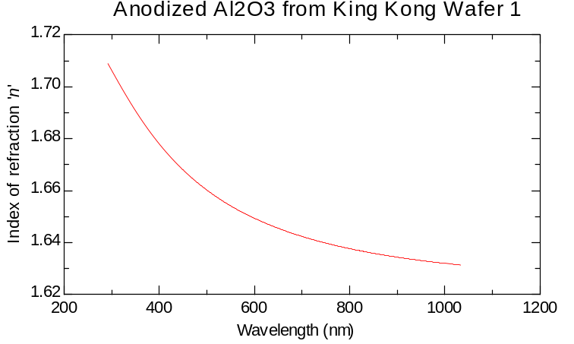

Sample 2: wafer02_kingkong_al2o3_20081201

Index at 6328 Å is 1.6516

MSE=52.21
Thick.1 1608.86±1.75
An.1 1.6272±0.000983
Bn.1 0.01033±0.000205
Cn.1 -0.00023131±1.95e-005
Ak.1 0.0068556±0.00132
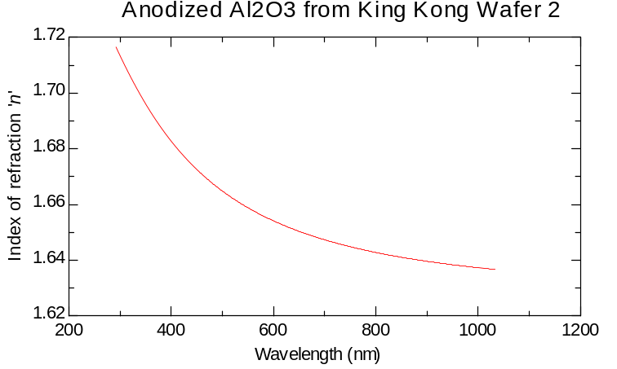
Bk.1 0.54832±0.0925

Sample 3: wafer03_kingkong_al2o3_20081201

Index at 6328 Å is 1.6466

MSE=57.01
Thick.1 1623.76±1.92
An.1 1.6204±0.00106
Bn.1 0.011284±0.000223
Cn.1 -0.00032592±2.13e-005
Ak.1 0.010469±0.00143
Bk.1 0.53395±0.0641

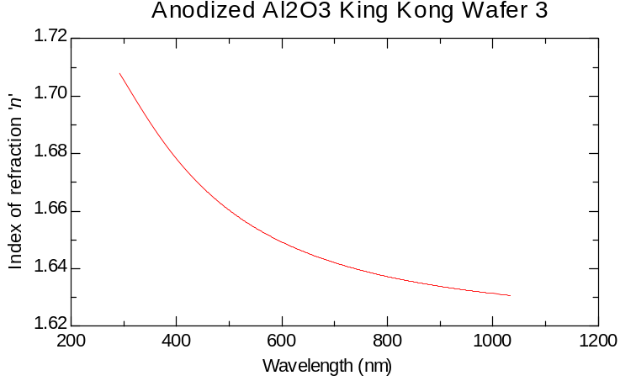
Sample 4: wafer04_kingkong_al2o3_20081201
Index at 6328 Å is 1.6476

MSE=41.41
Thick.1 1607.26±1.41
An.1 1.6242±0.000774
Bn.1 0.0097824±0.000164
Cn.1 -0.00017011±1.56e-005
Ak.1 0.0068673±0.00104
Bk.1 0.49117±0.0669

